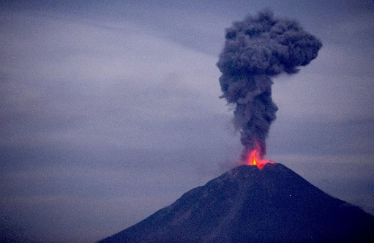Earthquake Teaching Assignment

You and your partner are tasked with teaching a group of students about Earthquakes. This will count towards both process grades and your product grades. Your group will need to create:

|  |  |
| --- | --- |
| Process (50 Points) | Product (50 Points) |
| Reading Assignment (10 pts) | 10 REM and 5 UND Questions (10 pts) |
| Thinking Notes (10 pts) |  |
| Video & Questions (10 pts) | Final Presentation (Lecture) (40 pts) |
| In-class Activity (10 pts) |  |
| Draft Presentation &  Guided Notes / Graphic Org (10 pts) |  |

# Process Grades

Each of the following items must be unique to your group. For example, two groups cannot use the same video or in-class activity.

* Reading Assignment: Identify a reading assignment that gives the student knowledge they need about at least one complete section of *Presentation Contents*.
* Thinking Notes: Create a Thinking Notes “exemplar” demonstrating what the students should have done if they did the marked the reading correctly.
* Find a video (> 8 minutes) covering at least one section of *Presentation Contents*and create five (5) questions from the video for students to answer (to keep them interested!)
* In-class Activity. Find an Activity for the students to do after the presentation to reinforce some or all of the Earthquake vocabulary and concepts presented during the PowerPoint presentation
  + Note: NOT a Word Search unless there is significantly more involved.
* Guided Notes or a Graphic Organizer: Based on a draft of your PowerPoint presentation, create guided notes or a graphic organizer that guides the student to write down the most important information from the lecture.

# Product Grades (50 Points)

* 10 REM and 5 UND Questions (10 points): In MS Forms, write 10 Remember (multiple-choice) questions and 5 Understand (short answer) questions with the correct answers marked as an Answer Key.
* Final Presentation / Lecture (40 Points). As a group, present your final PowerPoint Presentation. Use the guidelines listed in the *Presentation Contents* section below. The grading will be broken down as follows:

|  |  |  |
| --- | --- | --- |
| Lecture Participation | 5 Points |  |
| Ability to Answer Questions | 5 Points |  |
| Contents: Section 1 | 5 Points |  |
| Contents: Section 2 | 10 Points |  |
| Contents: Section 3 | 10 Points |  |
| Contents: Section 4 | 5 points |  |

# Presentation Contents

Your presentation must include:

1. Section 1: Earthquake Basics
   1. What are Earthquakes
   2. What causes Earthquakes
   3. Where are Earthquakes commonly found
2. Section 2: Describing Earthquakes
   1. What is Magnitude
   2. What are Aftershocks
   3. Epicenter of a quake
   4. Focus of a quake
3. Section 3: Recording earthquakes
   1. What are Seismic Waves and what are the Types of Waves (minimum of 2)
   2. How do scientists “sense” and measure Seismic Waves
   3. How are they useful to scientists
   4. How do scientists find the epicenter (I.e., triangulation)
4. Section 4: Examples of Earthquakes (Notable, recent and/or local quakes)
   1. At least one from Maryland
   2. One from the US >6.0 Magnitude
   3. One international quake > 6.0 Magnitude